
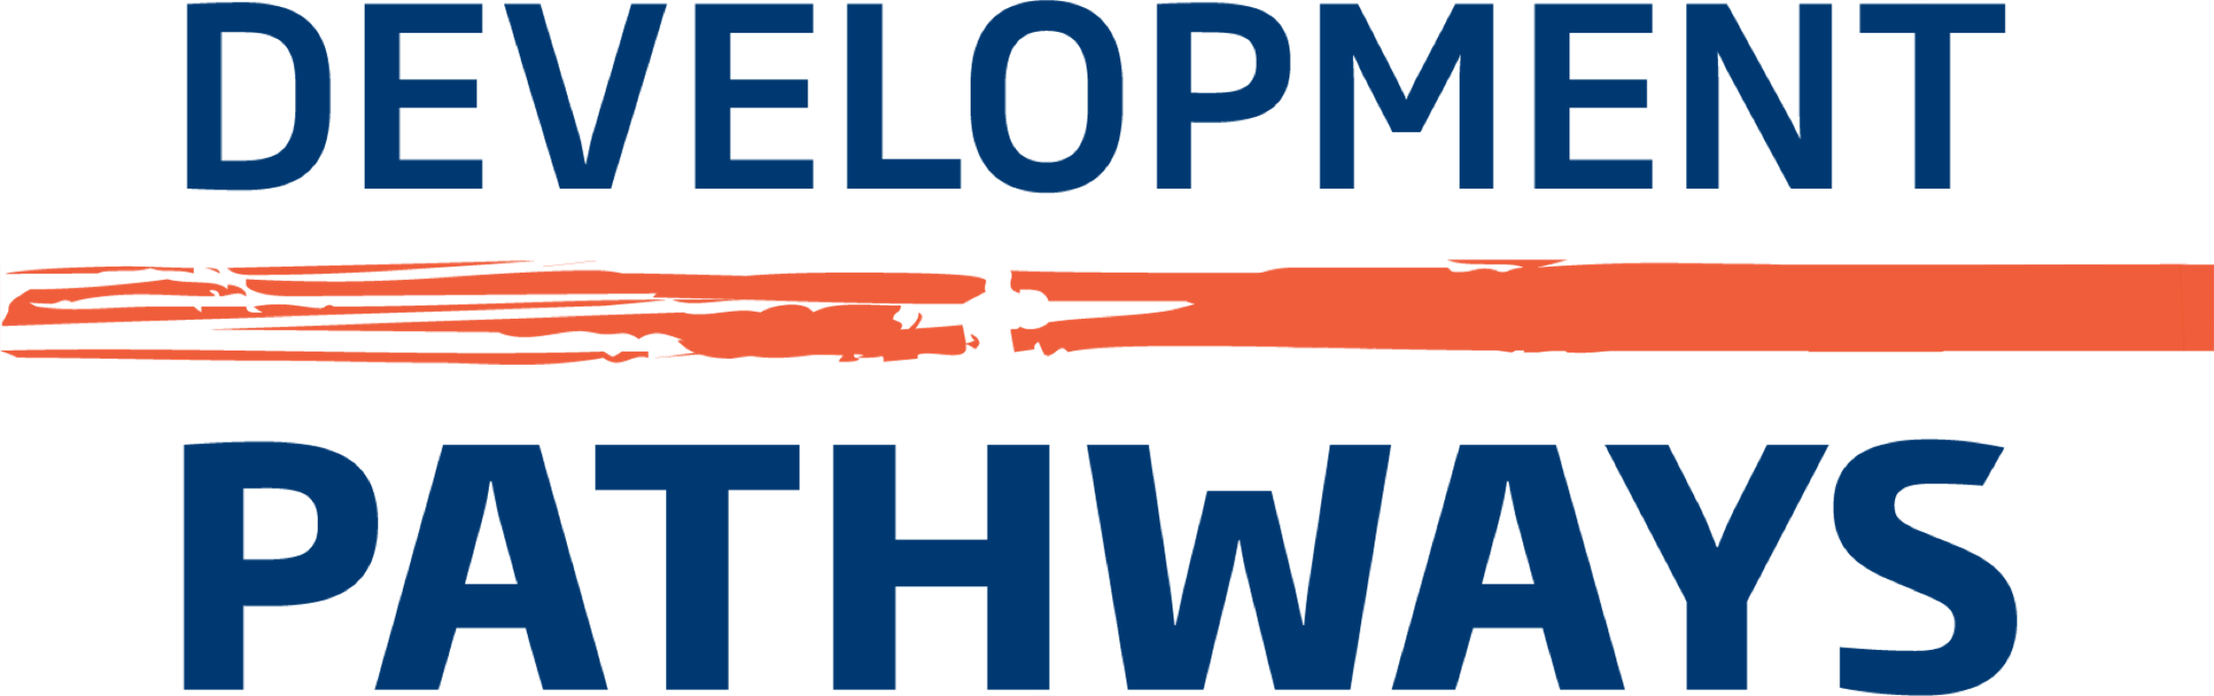

Krystle Kabare Scholarship Application Form 2020

Please type/fill in your answers into the allocated sections. If a section does not apply to you, kindly indicate (N/A). Do not leave any sections blank.
Please send the duly filled application form, including supporting documentation to scholarship@developmentpathways.co.uk

Basic Information
Surname: |  | Other Name(s):
Full address – current residence:

Permanent residence (if different from above)
Telephone number: |  | Mobile:
Personal email:
Where did you learn about this Scholarship?
Whilst interviews will most likely be virtual, due to physical distancing, please tell us if you would require any specific arrangements if invited to an in-person interview:

Do you have Kenyan citizenship or permanent residency?  Please delete as appropriate | Yes | No

Education Background
  - Formal education
Please indicate your education background, including all Colleges and Universities attended to date, and final grade upon graduation.
Date Completed | University/Professional body | Location | Subjects and Qualification | Final Grade

Training courses attended
Please note any training courses that you have taken, outside of University coursework, that are relevant to your chosen Master’s programme.
Date | Course Title

Master’s programme that you intend to study
This should be for a Master’s programme for which you have been accepted. Please indicate if there is more than one Master’s programme for which you have received an acceptance.

First Choice
Master’s Programme Name | Faculty and Department | Qualification (e.g. MSc, MPH etc) | Concentration/Main Focus

Second Choice
Master’s Programme Name | University/Professional body | Qualification (e.g. MSc, MPH etc) | Concentration/Main Focus

Language Proficiency
Please indicate what languages you speak and your proficiency level.
Language | Proficiency Level  elementary / moderate / fluent / native

Supporting Statements
Complete all essays in this section to the best of your ability.

Personal Statement (in no more than 500 words)
Please tell us why this Scholarship programme is for you. Suggested questions to answer in your Statement could include:
Why you are applying for this Scholarship?
How do you embody the values of Krystle Kabare?
How will this Scholarship contribute to your long-term goals?

Supplemental Essay Questions (in no more than 500 words each)
Who is your role model, and why?

Please share your vision on how you believe the Kenyan social policy landscape needs to be strengthened

Supporting Documentation
Please indicate that you have included the following in your email to us:
Document | Attached (Yes/No)
Confirmation of Kenyan Citizenship (ID/Passport)
Undergraduate Transcript Indicating Upper Second-Class Honours or above
Proof of Admission to Master's Programme of Choice
Three signed professional Letters of reference

DECLARATION
I certify that all the information that I have provided on this form is accurate to the best of my knowledge. I agree to give proof of the information stated on this application if requested. I give permission for the selection committee to review the information on this form, transcripts, and any additional supporting documentation submitted as part of this application. I give consent for the selection committee to contact University officials for additional academic information.

If chosen for the Scholarship award, I agree to provide proof of grades to the committee at each semester/quarter break so that the committee can determine my future eligibility, in addition to adhering to all Scholarship retention stipulations.

Signature: |  | Date:

Thank you for taking the time to fill out this application.
We look forward to learning more about you through your responses!
Best wishes from the family of Krystle Kabare and the Development Pathways team.

